*ESCINC Subcontract # 15-31*

*Task Order # 9*

# **Task 2 – Development of Evaluation Strategies**

# **First Draft for the Summary of Developed Evaluation Strategies for Improved Infrastructure Assessment through the Integration of Nondestructive Evaluation (NDE) and Structural Health Monitoring (SHM) Paradigms**

Franklin Moon, Saeed Babanajad, Nenad Gucunski

25 April 2019

*This draft report was developed to satisfy the requirements of Subtask 2, Task Order 9 issued by the Engineering & Software Consultants Inc. under the Subcontract # 15-31.*

## Introduction

The purpose of this Task is to establish an evaluation framework in order to assess the proposed integration strategies that were developed during Task 1. To develop a successful evaluation strategy, it is necessary to 1) conduct a sensitivity analysis through a numerical simulation to establish the sensitivity of structural demands (i.e. the distribution of live load force effects) and capacity (i.e. member capacity) to the presences of various types and sizes of local deterioration, 2) upon the outcomes of the first step, identify valuable field data sources (in terms of SHM, NDE, and visual inspection) and prepare them for integration through the proposed integration strategies (IS1-IS8) developed in Task 1. The primary metric to quantify the benefit/importance of the proposed NDE/SHM integration platform is to compare it against the current AASHTO MBE approach within the overall bridge load-rating practice.

## Proposed Evaluation Strategy Framework

The proposed evaluation strategy is broken into two tasks. The first, *Task 2.1 – Numerical Simulation*, aims to establish the sensitivity of structural demands (i.e. the distribution of live load force effects) as well as the member capacity to the presence of various types and sizes of local deterioration. This activity will permit the identification of the type and extent of deterioration (together with spatial thresholds) that should be included within the validation datasets used within Task 2.2.

The second task, *Task 2.2 – Validation with Field Data*, will aim to evaluate the eight integration strategies identified under Task 1 using data from operating bridges. It is envisioned that bridges from the LTBP Program (Mid-Atlantic, Northwest, Pilot, and International Bridge Study) as well as the BEAST specimen will be used during this subtask. Importantly, all datasets that will be used for the validation will meet or exceed the deterioration thresholds set in Task 2.1. In cases where sufficient datasets are not available, data sets may be “scaled” by either amplifying magnitude or spatial size to meet the identified thresholds.

The details of all the above activities for conducting a successful evaluation strategy are discussed in the following subsections, however, the actual implementation of each will be addressed in Tasks 3 and 4.

### Task 2.1 Numerical Simulation

Before starting to use field data to assess the proposed integration strategies (developed under Task 1), it is beneficial to first conduct a simulation to measure the sensitivity of structural demands (i.e. the distribution of live load force effects) and member capacity to the presences of various types and sizes of local deterioration. To accomplish this, the following two activities will be carried out.

#### Task 2.1.1 - Establishing the Influence of Local Deterioration on Structural Demands

The goal of this set of activities will be to establish the sensitivity of structural demands (i.e. the distribution of live load force effects) to the presences of various deterioration types. To accomplish this, two high resolution, geometric-replica FE models of common bridge types will be developed. It is envisioned that that these two models will focus on the following two bridge types:

* Simply-supported, pre-stressed concrete multi-girder bridge
* Simply-supported, steel multi-girder bridge

To ensure these models are representative of common bridges, their characteristics will be selected based on the median values of their respective bridge type in NBI. Table 1 provides the recommended bridge properties based on the NBI database. The simulated models (Figure 1) would be developed in a way to meet the requirements of the proposed model resolution in Task 1.

**Table 1 Properties summary of the simulated bridges**

|  |  |  |
| --- | --- | --- |
|  | **Pre-stressed Concrete** | **Steel Girder** |
| **Total Length (ft)** | 120 | 120 |
| **Total Width (ft)** | 45 | 45 |
| **Number of Lanes** | 2 | 2 |
| **Average Daily**  **Truck Traffic (ADTT)** | 1200 | 1200 |
| **Girder Spacing (ft)** | 7.5 | 7.5 |
| **Girder Depth (ft)** | 4.8 | 4.8 |
| **Girder Size** | LFRD - New Jersey | LFRD - New Jersey |
| **Deck Thickness (in)** | 8 | 8 |

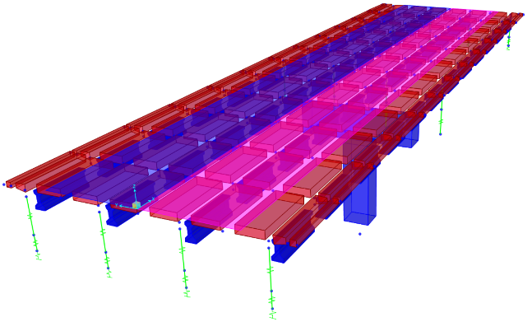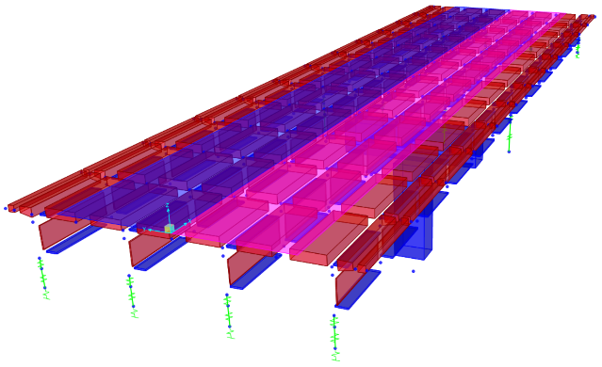

**Figure 1 Simulated pre-stressed concrete (left) and steel (right) multi-girder bridges**

It is expected that these models will be constructed in Abaqus using solid elements to permit explicit simulation of common types of deterioration, including:

* Deck delamination
* Deck concrete degradation manifest as a loss of elastic modulus
* Local loss of composite action (associated with significant deck deterioration)
* Section loss of girder ends

This activity will progress by first establishing the live load force effects of the intact bridge model, and then proceed by rerunning the simulations with varying levels of deterioration included within the model. The primary metric used to quantify the sensitivity will be the percentage change of force effects between the intact and deteriorated models.

To structure this sensitivity study, deck deterioration will be focused on two spatial locations: (a) mid-span center of the deck, and (b) mid-span side (shoulder) of the deck. For each of these locations, the level of deck deterioration will be incrementally increased to establish the sensitivity on the live load force effects. For girder deterioration, the locations examined will be limited to the girder ends, which is the most common location for deterioration observed in the field (due to leaky joints). Figure 2 below demonstrates some of the common deterioration types occur in highway bridges. The ultimate outcome of this activity will be a set of thresholds for different types of deterioration that reflect both the magnitude and spatial size that could be expected to impact the distribution of demands.

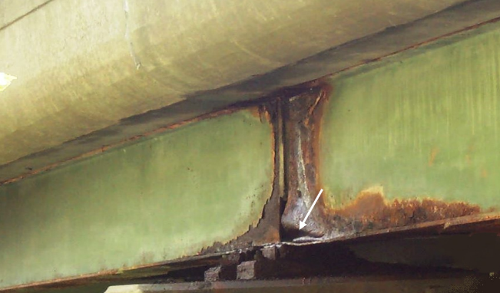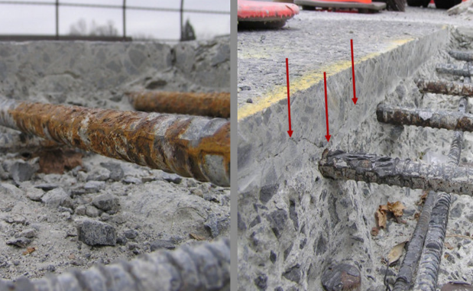

**Figure 2 Samples of girder (left) and deck (right) delamination**

#### Task 2.1.2 – Establishing the Influence of Local Deterioration on Member Capacity

The goal of this task will be to establish the sensitivity of element capacity to common types of local deterioration (see Task 2.1.1). This subtask will be carried out in a similar manner to Task 2.1.1, except instead of using models of the entire bridge (with are needed for demand estimation), this subtask will focus on cross-sectional models capable of estimating the capacity of individual members. To assess the sensitivity of capacity to deterioration, the percent difference between an intact model and the model that includes deterioration will be computed.

For this application, the use of a cross-sectional model termed a fiber model will be employed. This model is commonly used for nonlinear flexural analysis of complex cross-sections, which it handles by discretizing the cross-section into a number of elements referenced to specific stress-strain models. Through incrementally increasing the curvature on the cross-section (together with assumptions of plane-sections-remain-plane and iterating until equilibrium is satisfied) a nonlinear moment-curvature response is obtained. Fig. 3a schematically shows a section of multi-girder composite bridge with a cross-sectional cut. Fig. 3b provides a closer look at the fiber cross-section, where all the girder and deck elements are meshed into finer 2D elements. In parallel to the implementation of Task 2.1.1, each type of delamination introduced to the simulated demand model will be defined to the fiber model as well, and the capacity of the corresponding structural element will be determined.

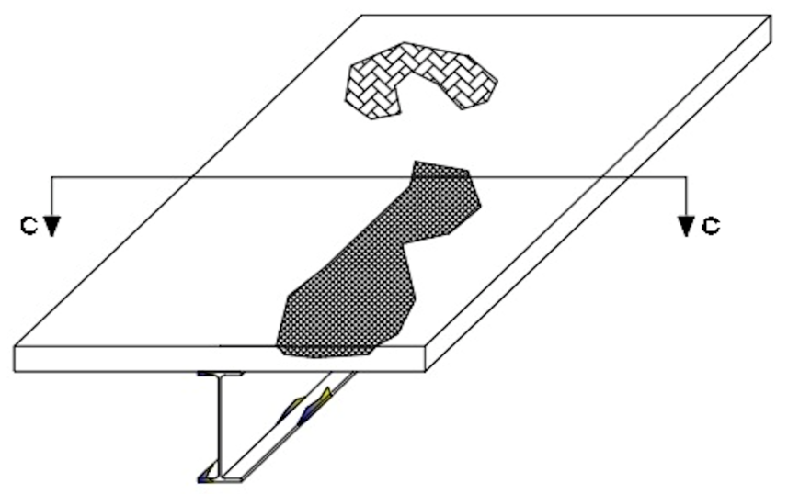

(a)

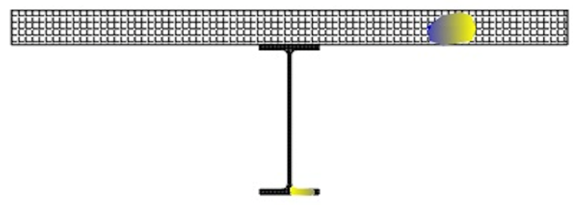

(b)

**Figure 3 a) 3-D schematic of a deteriorated bridge, b) fiber model for a critical cross-section (C-C)**

To quantify the sensitivity of capacity to local deterioration, two metrics will be used. The first will be a percent difference between the capacity associated with an intact model and each deteriorated model. Th second will be an assessment of the influence of deterioration on the failure mode/ductility of the element. In cases where the failure model/ductility is appreciably influenced, the resistance factors may need to be revisited (since a larger safety index is generally assigned to more brittle failure modes).

The ultimate outcome of this activity will be a set of thresholds that define the magnitude and spatial size of local deterioration that may be expected to influence member capacity.

### Task 2.2 Validation with Field Data

The goal of this task will be to quantitatively establish the benefits of directly including both NDE and SHM data to update global (demand) and localized (capacity) models. Specifically, this task will evaluate and validate the eight (8) integration strategies identified under Task 1 using data from operating bridges. It is envisioned that bridges from the LTBP Program (Mid-Atlantic, Northwest, Pilot, and International Bridge Study) as well as the BEAST specimen will be used during this subtask. To organize the activities associated with this task, the following four subtasks have been identified.

#### Task 2.2.1 – Identification and Preparation of Field Data

The goal of this task will be to identify and prepare field datasets for inclusion within the evaluation and validation activities. As mentioned previously, up to three bridges with both SHM and NDE data will be included within this study. The goal will be to locate datasets that meet the thresholds defined in Task 2.1 and thus would represent levels of deterioration that may be expected to influence both demand and capacity. In cases where sufficient datasets are not available, data sets may be “scaled” by either amplifying magnitude or spatial size to meet the identified thresholds. If this proves to be necessary, the Rutgers team will work closely with the FAST NDE Lab to ensure all scaling/amplifying approaches are acceptable.

#### Task 2.2.2 - Establishing the Value of NDE-SHM Integration for Demand Estimation

The goal of this task will be to quantitatively establish the benefits of directly including NDE data (together with SHM data) to update global models to estimate live load force effects. This will be accomplished by carrying out the eight (8) integration strategies described under Task 1 (see Table 2), on three datasets identified in Task 2.2.1 in two ways. The first will include the use of both SHM and NDE while the second approach will only include the use of SHM data. This will permit the value of including NDE data within the model updating process for demand estimation to be quantified.

**Table 2 Proposed NDE-SHM integration strategies (Task 1)**

|  |  |  |  |
| --- | --- | --- | --- |
| **Integration Strategy (IS)** | **Type of Data** | **Model Resolution** | **Model Updating** |
| **IS#1** | SHM data for demand models, NDE for capacity models | Element level model (single beam element for girder) | LHS + percent weighing |
| **IS#2** | SHM data for demand models, NDE for capacity models | Element level model (single beam element for girder) | MCMC + Bayes rule |
| **IS#3** | SHM data for demand models, NDE for capacity models | Refined model (shell element for girder) | LHS + percent weighing |
| **IS#4** | SHM data for demand models, NDE for capacity models | Refined model (shell element for girder) | MCMC + Bayes rule |
| **IS#5** | SHM + NDE (damage functions) for demand models, NDE for capacity models | Element level model (single beam element for girder) | LHS + percent weighing |
| **IS#6** | SHM + NDE (damage functions) for demand models, NDE for capacity models | Element level model (single beam element for girder) | MCMC + Bayes rule |
| **IS#7** | SHM + NDE (damage functions) for demand models, NDE for capacity models | Refined model (shell element for girder) | LHS + percent weighing |
| **IS#8** | SHM + NDE (damage functions) for demand models, NDE for capacity models | Refined model (shell element for girder) | MCMC + Bayes rule |

In addition to each of the eight (8) integration strategies, a nominal model (assuming as built dimensions and material properties) will also be employed to estimate the demands for each of the three bridges. These demand estimates will serve as a control and will be compared against the two set of demands estimated using the eight integration strategies.

The primary metric to quantify the benefit/importance of NDE/SHM integration (as well as the effectiveness of each integration strategy) for the estimation of demands will be the percent difference in live load force effects between the nominal model and (a) models updated with NDE/SHM data and (b) models updated with only SHM data.

#### Task 2.2.3 - Establishing the Value of NDE Data for Capacity Estimation

The goal of this task will be to establish the influence of directly including NDE data to estimate the capacity of structural elements, this time by using the actual NDE data collected from real bridges. The same fiber model, as well as the metrics for evaluation utilized in Task 2.1.2 will be utilized to determine the capacity of the members based on the type of delamination diagnosed by different NDE techniques.

#### Task 2.2.4 – Evaluation Strategy for Overall Load Rating

Task 2.2.2 and 2.2.3 addressed the influence of incorporating both SHM and NDE data within the primary steps of a load rating analysis. Under this task, the results of these tasks will be combined to identify the overall influence of integrating NDE and SHM data for the load rating of bridges. This will be accomplished through calculating rating factors as shown in Table 3 (for each of the eight integration strategies).

**Table 3 Proposed NDE-SHM evaluation strategies**

|  |  |  |
| --- | --- | --- |
|  | **Demand Estimation** | **Capacity Estimation** |
| **Control** | AASHTO MBE | AASHTO MBE |
| **Approach 1** | Inclusive of SHM data only (Task 2.2.1: IS1-IS4) | AASHTO MBE |
| **Approach 2** | Inclusive of both NDE and SHM data (Task 2.2.1: IS5-IS8) | AASHTO MBE |
| **Approach 3** | AASHTO MBE | Inclusive of NDE data (Task 2.2.2) |
| **Approach 4** | Inclusive of SHM data only (Task 2.2.1: IS1-IS4) | Inclusive of NDE data (Task 2.2.2) |
| **Approach 5** | Inclusive of both NDE and SHM data (Task 2.2.1: IS5-IS8) | Inclusive of NDE data (Task 2.2.2) |

By examining the percent differences between the rating factors between Approaches 1-5 and the Control, the importance of including various combinations of NDE and SHM data will be established.

## References

* AAHSTO (2018). “Manual for Bridge Evaluation (MBE).” American Association of State Highway and Transportation Officials (AASHTO), 3rd Ed., Washington, DC.